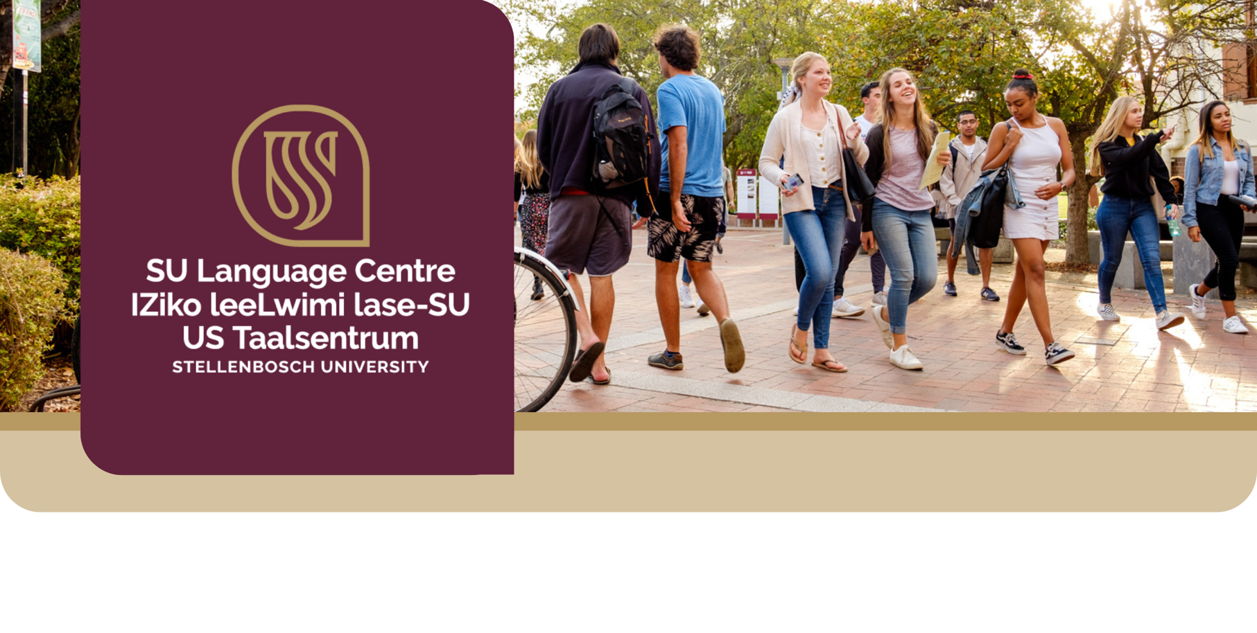


Campus Afrikaans
A Certificate of Attendance short course

Are you a non-mother tongue speaker of Afrikaans with no prior knowledge of Afrikaans, and a registered student at Stellenbosch University? Consider joining this interactive short course to learn some basics Afrikaans that you can use with fellow students on and around campus!
What is the focus of this course?
You will be able to use Afrikaans in a very basic and functional manner. You will gain a basic Afrikaans vocabulary for use in campus-related communication and specific emphasis will be placed on speaking, listening, and reading. As part of the larger university context, you will also gain an understanding of the cultural value of multilingualism. This crash course is practical and interactive, and campus-related scenarios are incorporated to encourage the use of authentic language.
Topic 1 | Topic 2 | Topic 3 | Topic 4 | Topic 5
Introduction | Greeting & Health | Personal information | Social interaction | In and around town
The crash course is presented on Stellenbosch campus over a period of 8 weeks. The face-to-face time includes authentic and interactive language use activities where participants get the opportunity to practise the target language in real life situations.
Face-to-face contact time = 16 hours (2 hours per week) | Online activities = 16 hours (2 hours per week of autonomous learning)

Interested? Click here to fill in the online application form. We will send you further instructions after receiving your form.


What are the prerequisites?
Registered students at Stellenbosch University. Strictly non-mother tongue speakers of Afrikaans with no prior knowledge of Afrikaans should register for this fun and informal course. Access to internet, Wi-Fi or mobile data is essential for the online component.
A certificate of attendance will only be awarded after successful completion of the course. Participants are required to attend the full duration of the course. Additionally, a minimum of 80% of the online work must be successfully completed.
A certificate of attendance will only be awarded after successful completion of the course. Participants are required to attend the full duration of the course. Additionally, a minimum of 80% of the online work must be successfully completed.
What are the course outcomes?
Upon successful completion of the course, you should be able to do the following in Afrikaans:
- greet and introduce yourself,
- provide basic personal information such as name, age, address, and telephone number,
- ask and respond to basic questions,
- have basic conversations with other students, and
- use basic vocabulary related to campus life.
When will the course take place?
The dates and times for the 2026 offerings are:
 | Course start date | Time and day | Enrol by
Semester 1 | Week of 02 March | 17:15 – 19:15 (Tuesdays OR Thursdays) | 13 February
Semester 2 | Week of 03 August | 17:15 – 19:15 (Mondays OR Tuesdays) | 29 May

What does the course cost?
Participants who enrol for this course will be sponsored by funding which includes the registration fee, all course material, access to the online platform and refreshments.
Stellenbosch University provides a selection of fully funded short courses to students and staff. While participants do not pay out of pocket, these courses are funded by the university or private sponsors. Every enrolment represents a valuable learning opportunity, and non-attendance without valid reasons takes away a spot from someone who is committed to completing the course. To ensure responsible use of these resources, participants must carefully assess their workload before enrolling. Attendance at all sessions is required for successful completion of the course. By enrolling in a funded short course, you acknowledge and agree to these terms, including full attendance requirements and responsible participation.
Please refer to the next page for important attendance and cancellation guidelines.

Please refer to the Attendance and Cancellation policy and agreement on the next page.

Attendance and Cancellation policy and agreement
- Attendance guidelines
Valid reasons for absence from a session includes formal assessments, other formal university functions, family responsibilities or illness. For assessments and other functions, proof must be provided at least 1-2 weeks prior. For family responsibilities or illness proof must be provided one day after.

- Cancellation guidelines
If you need to cancel your enrolment, you must inform the Stellenbosch University Language Centre via email, clearly stating your intention to withdraw and providing a reason for discontinuation: Mrs. Helga Sykstus – hbuys@sun.ac.za

Cancellation deadlines:
- Before or during Week 2 of the course: You may cancel your enrolment and will be eligible to enrol in a similar course in the future.
- After Week 2 of the course: You will receive an incomplete for the short course and will not be permitted to enrol in a similar course again.

