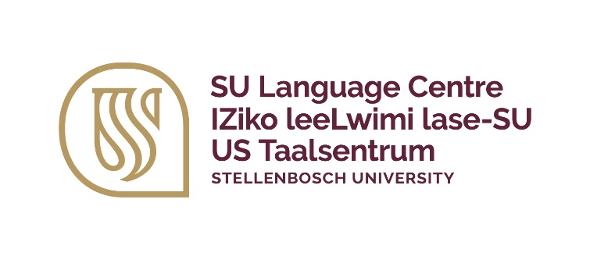 | Stembele Johnson  ssjohnson@sun.ac.za  +27 (0)21 808 9097
IsiXhosa portfolio | IPotfoliyo yesiXhosa | Xhosa-portefeulje
Masabelane Elementary A2
A certificate of competence short course

What are the course objectives?
This course targets Stellenbosch University staff members with a beginner's knowledge of isiXhosa. This is a fun-filled course offering you a linguistic and cultural taste of isiXhosa as a language in a wider cultural context. This course will go deep into the grammar of the language while Masabelane A1 provides the vocabulary needed to converse on a daily basis.

Who should attend?
This course is offered to Stellenbosch University staff members who have completed Masabelane A1. Non-mother tongue speakers of isiXhosa who would like to extend their knowledge of isiXhosa should register for this course. Prospective participants who have not completed Masabelane A1 can apply but will need to complete and oral assessment before being allowed to continue with the course.

Any prerequisites?
Access to internet, Wi-Fi or mobile data is essential.

How is this course presented?
The course will be taught through face-to-face sessions over the course of 12 weeks and includes self-paced learning (tasks and activities). The face-to-face sessions will be interactive, and the facilitator will engage with all participants. The facilitator will utilise the face-to-face sessions to present the course content and interact with you while you complete class-based activities and tasks that will apply your knowledge.

Depending on the delivery mode of this course, you might also be given access to our online learning platform so that you will have access to course resources and will be able to complete certain activities.

The primary language of teaching and learning of this course will be English (instruction), with occasional switching to isiXhosa for learning purposes.

Face-to-face contact time = 24 hours (2 hours per week for 12 weeks)
Online and autonomous learning = 12 hours (1 hour per week)

Week 1 | Week 2 | Week 3 | Week 4
Introduction, greeting and getting to know each other | Introduction, greeting and getting to know each other | More about myself  Nouns and possessives | Advice, suggestions and requests  Imperatives
Week 5 | Week 6 | Week 7 | Week 8
Telling time and sharing experiences – past and future  IsiXhosa tenses and forms | Explaining actions  Some isiXhosa verbs Formative | Describing things and places  Adjectives | The places where we come from  Adverbs
Week 9 | Week 10 | Week 11 | Week 12
Giving instructions and pointing out items  Copulatives | IsiXhosa songs | Revision | Oral assessment  Grammar assessment

What are the course outcomes?
- Communicate in simple and routine tasks requiring a simple and direct exchange of information on familiar topics and activities Read short, simple texts.
- Write short, simple notes and messages.
- Handle very short social exchanges.
- Identify the gist of social conversations.
- Identify the gist of short texts.
- Demonstrate knowledge of basic grammar, vocabulary and idiomatic expressions.

A certificate of competence will only be awarded after successful completion of the course. Participants are required to dedicate themselves to this accredited short course by attending the full duration of the course.

When will this course take place?
2025 Full time course dates | Registration and payment deadlines | Venue
24 March – 12 June 2025 | 3 March – 17 March 2025 | TBC
18 August – 6 November 2025 | 28 July – 11 August 2025 | TBC

What does the course cost?
The course cost is R3 688 per participant, including study material.

Further questions?
For more information, contact Ms Stembele Johnson at ssjohnson@sun.ac.za or 021 808 9097.

