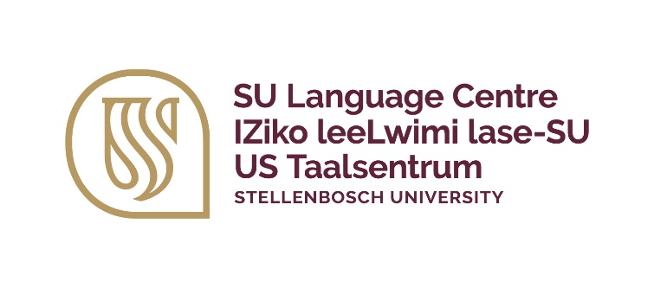 | Stembele Johnson  ssjohnson@sun.ac.za  +27 (0)21 808 9097
IsiXhosa portfolio | IPotfoliyo yesiXhosa | Xhosa-portefeulje
Masabelane Beginner A1
A certificate of competence short course

What are the course objectives?
In this course participants will be able to use isiXhosa in a basis and functional manner on campus. They will gain a basic isiXhosa Vocabulary for use in campus-related communication and specific emphasis will be placed on speaking, listening, and reading. As part of the larger university context, they will also gain an understanding of the cultural value of multilingualism. This is course is practical and interactive, and campus-related scenarios are incorporated to encourage the use of authentic language.

Who should attend?
This course is offered to Stellenbosch University staff members. Non-mother tongue speakers of isiXhosa who would like to be able to converse in basic isiXhosa should register for this course.

Any prerequisites?
Access to internet, Wi-Fi or mobile data is essential.

How is this course presented?
The course is presented face-to-face over a period of 8 weeks, where participants get the opportunity to practice the isiXhosa and conversate with other participants. The course will provide participants with the basic vocabulary to use in conversation around campus and the community.

Attendance?
This is an attendance course therefore participants are expected to only miss 2 sessions over the 8 weeks period. Failure to do so may result in one not getting a certificate.

Face-to-face contact time = 16 hours (2 hours per week for 8 weeks)
Online activities = 12 hours (1 hours per week of autonomous learning)

Week 1 | Week 2 | Week 3 | Week 4
Introduction and greeting | Personal Details | The state of the weather | Days of the week  Months of the year
Week 5 | Week 6 | Week 7 | Week 8
Ordering something to drink and eat | At the garage | At the clothing store | Revision and Oral assessment

What are the course outcomes?
At the end of this course, the participants will be able to do the following:
• Greet and introduce yourself
• Provide basic personal information
• Ask and respond to basic questions
• Have a basic conversation with other isiXhosa speaking individuals
• Communicate socially on a basic level, and
• Use basic vocabulary related to everyday life

A certificate of competence will only be awarded after successful completion of the course. Participants are required to dedicate themselves to this accredited short course by attending the full duration of the course.

When will this course take place?
2025 short course dates | Registration and payment deadlines
4 February – 26 March 2025 | 13 January – 27 January 2025 | TBC
8 April – 28 May 2025 | 17 March – 31 March 2025 | TBC
15 July – 3 September 2025 | 23 June – 7 July 2025 | TBC
16 September- 5 November 2025 | 25 August – September | TBC

What does the course cost?
The course is currently FREE.
The course cost is R3 688 per participants, including study material.

Further questions?
For more information, contact Ms Stembele Johnson at ssjohnson@sun.ac.za or 021 808 9097.

